Read and Respond

Reading is an important part of your education, so you will be expected to spend time each week reading a book of interest to you, and responding to it in a journal. In order to get credit for Read and Respond (R&R), you will be required to follow these guidelines carefully.

- Choose a book for R&R that is appropriate for your reading abilities and interests. If you cannot find a book, you will be assigned a book whether you like it or not. No magazines, comics, or picture books are allowed.
- Bring your book to class everyday. When you finish work in class you will be expected to take out your book and read. You may be given class time to read, although you should not count on having class time to complete your independent reading assignment.
- You must read at least 80 pages, however, you should be reading more. Your homework is to read at least 20 minutes every night. You are to turn in your R&R journal bi-weekly (every two weeks).
- One full page must be the summary of what you read. It must be done in model #4 format. Another full page will be your thoughts and feelings about what you are reading. (See response starters below).
- If a book is too difficult or you do not like it, give it fifty pages and then see me. Do not abandon a book until you have discussed it with me. If you get to an uninteresting part, try skimming that section and see if the story picks up.
- A parent signature is required to prove that you read the required amount of time.
- You will receive up to 40 points credit every two weeks for your written journal.
The points earned are as follows:
  - 5 points for parent signature
  - 5 points for correct heading: book title pages ______ to ____ date:
  - 20 points for a correct summary
  - 10 points for correct responses
- You are to read at least 20 minutes at home each day; a good time is just before bed. You will be astounded at the progress you make and the goods you will enjoy!

Response Starters:
I notice … What if …
I wonder … I didn’t like the way …
It seems like … I wonder why the author …
I understand … I learned …
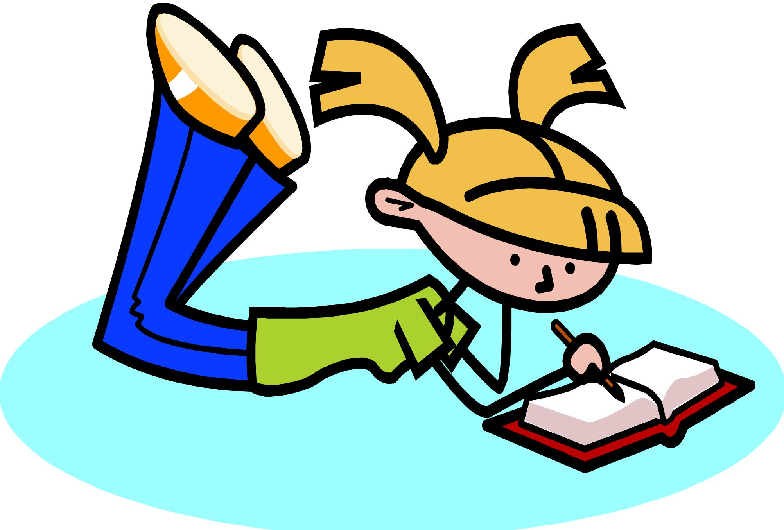
If I were … I found it interesting …
I love the way … I felt …
I think … I predict …
I wish … A question I have is …
I was surprised …

Use at least 3 different starters and answer them fully for a good, complete response.

